**Lab Assignment#3:**

**Question1:**

**Code:**

/*  
Name: !you   
Regstration No: SP21-BCS-OO2  
Lab Assignment: string array menu  
*/  
import java.util.*;  
import java.lang.*;  
public class LabQ1{  
 public static void main(String[] args){  
 Scanner input = new Scanner(System.in);  
  
 System.out.println("Enter the length of the array! ");  
 int length = input.nextInt();  
 String[] array = new String[length + 1];  
  
 System.out.println("Enter the array elements! ");  
 for(int i = 0; i < array.length; i++){  
 String user1 = input.nextLine();  
 array[i] = user1;  
 }  
  
 while(true){  
 System.out.println("\n------------ Menu ------------");  
 System.out.println("Your string array is:");  
 printArray(array);  
 System.out.println();  
 System.out.println(" Press 1 to Calculate length of string");  
 System.out.println(" Press 2 to Count number of words in string");  
 System.out.println(" Press 3 to Check a string is palindrome");  
 System.out.println(" Press 4 to Convert a string in lowercase.");  
 System.out.println(" Press 5 to Convert a string in uppercase.");  
 System.out.println(" Press 6 to Exit");  
   
 int user = input.nextInt();  
 if(user == 1){  
 System.out.println();  
 length(array);   
 }  
 else if(user == 2){  
 System.out.println();  
 words(array);   
 }  
 else if(user == 3){  
 System.out.println();  
 palindrome(array);   
 }  
 else if(user == 4){  
 System.out.println();  
 lowercase(array);   
 }  
 else if(user == 5){  
 System.out.println();  
 uppercase(array);   
 }  
 else if(user == 6){  
 break;   
 }  
 }  
  
   
 }  
 public static void printArray(String[] list){  
 for(int i = 0; i < list.length; i++){  
 if(i == 0){  
 System.out.println();   
 }  
 else{  
 System.out.println(" Index[" + (i) + "] " + list[i]);  
 }  
 }   
 }  
 public static void length(String[] list){  
 Scanner input = new Scanner(System.in);  
 System.out.println("Enter the Index of the Array to find its total length");  
 int user = input.nextInt();  
 int length = 0;  
 for(int i = 0; i < list.length; i++){  
 if(i == user){  
 length = list[i].length();  
 }  
 }  
 System.out.print("The length of[" + user + "] is " + length);  
 }  
 public static void words(String[] list){  
 Scanner input = new Scanner(System.in);  
 System.out.println("Enter the Index to find the word count");  
 int user = input.nextInt();  
 int length0 = 0;  
 int length1 = 0;  
  
 for(int i = 0; i < list[user].length(); i++){  
 if(list[user].charAt(0) == ' ' && list[user].charAt(i) == ' '){  
 length0++;   
 }  
 else if(list[user].charAt(i) == ' '){  
 length1++;  
 }  
 }  
 if(list[user].charAt(0) == ' '){  
 System.out.print("The length of words is: " + length0);  
 }  
 else{  
 System.out.print("The length of words is: " + (length1 + 1));   
 }  
 }  
 public static void palindrome(String[] list){  
 Scanner input = new Scanner(System.in);  
 System.out.println("Enter the Index to check the palindrome of String");  
 int user = input.nextInt();  
 String orignal = "";  
 String reversed = "";  
   
 // Storing String in orignal manner   
 for(int i = 0; i < list[user].length(); i++){  
 orignal += list[user].charAt(i);  
 }  
  
 // Storing String in reversed manner  
 for(int i = list[user].length() - 1; i > -1 ; i--){  
 reversed += list[user].charAt(i);  
 }  
  
 // checking if it is palindrome  
 if(orignal.equals(reversed)){  
 System.out.println("is palindrome");  
 }  
 else{  
 System.out.println("not palindrome");  
 }  
   
 }  
 public static void lowercase(String[] list){  
 Scanner input = new Scanner(System.in);  
 System.out.println("Enter the Index of the array for lowercase conversion ");  
 String orignal = "";  
 int user = input.nextInt();  
 for(int i = 0; i < list[user].length(); i++){  
 orignal += list[user].charAt(i);  
 }  
 System.out.println("Lowercase String is: " + orignal.toLowerCase());   
   
 }  
 public static void uppercase(String[] list){  
 Scanner input = new Scanner(System.in);  
 System.out.println("Enter the Index of the array for lowercase conversion ");  
 String orignal = "";  
 int user = input.nextInt();  
 for(int i = 0; i < list[user].length(); i++){  
 orignal += list[user].charAt(i);  
 }  
 System.out.println("Uppercase String is: " + orignal.toUpperCase());   
   
 }  
}

**Output:**

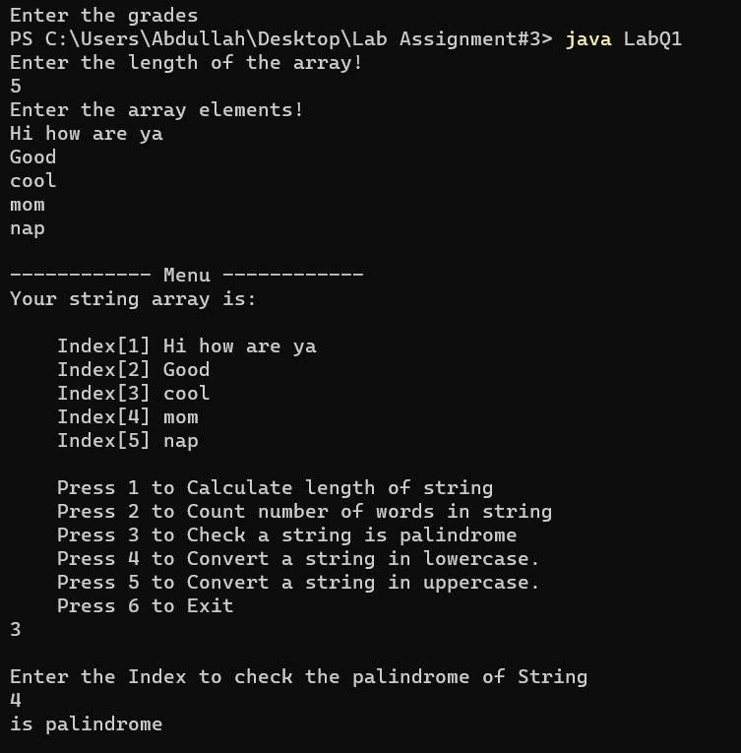

**Question2:**

**Code:**

/*  
Name: !you   
Regstration No: SP21-BCS-OO2  
Lab Assignment: Menu for students   
*/  
import java.util.*;  
import java.lang.*;  
public class LabQ2{  
 public static Scanner input = new Scanner(System.in);  
 public static void main(String[] args){  
  
 System.out.println("Enter the number of students");  
 int students = input.nextInt();  
  
 System.out.println("Enter the number of subjects");  
 int subjects = input.nextInt();  
  
 String[][] array = new String[students + 1][subjects + 1];  
 for(int row = 0; row < array.length; row++){  
 for(int col = 0; col < array[row].length; col++){  
 if(row == 0 && col == 0){  
 array[0][0] = " ";  
 }  
 else if(row == 0 && col != 0){  
 System.out.println("Enter the subjects[" + col + "]");  
 String user = input.next();  
 array[0][col] = user;  
 }  
 else if(row != 0 && col==0){  
 System.out.println("Enter the student name[" + row + "]");  
 String user2 = input.next();  
 array[row][col] = user2;  
 }  
 else{  
 System.out.println("Enter the grades");  
 String user3 = input.next();  
 array[row][col] = user3;  
 }  
  
  
 }  
 }  
 while(true){  
 System.out.println("\n------------ Menu ------------");  
 System.out.println("The [] Represents Index of Specfied Term\nInput starts with [1]");  
 System.out.println("Your Grades Table is:");  
 System.out.println("--------------------------------");  
 printArray(array);  
 System.out.println();  
 System.out.println("Press 1 to Calculate sum of specfied student ");  
 System.out.println("Press 2 to Calculate average of specfied subjects");  
 System.out.println("Press 3 to Calculate highest value in a row");   
 System.out.println("Press 4 to Calculate lowest value in a row");  
 System.out.println("Press 5 to Exit");  
   
 int user = input.nextInt();  
 if(user == 1){  
 System.out.println();  
 Total_marks(array);   
 }  
 else if(user == 2){  
 System.out.println();  
 Avg_Subject(array);   
 }  
 else if(user == 3){  
 System.out.println();  
 Stud_Highest(array);   
 }  
 else if(user == 4){  
 System.out.println();  
 Stud_Lowest(array);   
 }  
 else if(user == 5){  
 break;   
 }  
  
 }  
 }  
 public static void printArray(String[][] list){  
 for(int row = 0; row < list.length; row++){  
 for(int col = 0; col < list[row].length; col++){  
 /*String student = input.next();  
 System.out.printf("%1s" , student);*/  
 System.out.printf("%-10s" , list[row][col]);  
 }  
 System.out.println();  
 }   
 }  
 public static void Total_marks(String[][] list){  
 System.out.println("Enter the student index ");  
 int user = input.nextInt();  
 int sum = 0;  
 for(int row = 1; row < list.length;row++){  
 for(int col = 1; col < list[row].length; col++){  
 if(row == user){  
 sum = sum + Integer.parseInt(list[row][col]);  
 }  
 }   
 }  
 System.out.println(sum);  
   
 }  
 public static void Avg_Subject(String[][] list){  
 System.out.println("Enter the subject index ");  
 int user = input.nextInt();  
 int sum = 0;  
 for(int row = 1; row < list.length;row++){  
 for(int col = 1; col < list[row].length; col++){  
 if(col == user){  
 sum = sum + Integer.parseInt(list[row][col]);  
 }  
 }   
 }  
 System.out.println(sum);  
   
 }  
 public static void Stud_Highest(String[][] list){  
 System.out.println("Enter the student index ");  
 int user = input.nextInt();  
 int max = 0;  
 int index = 0;  
 for (int row = 1; row < list.length; row++) {  
 for (int col = 1; col < list[row].length; col++) {  
 if(Integer.parseInt(list[user][col]) > max) {  
 max = Integer.parseInt(list[user][col]);  
 index = col;   
 }  
 }  
 }  
 System.out.println("The highest value in the row is: " + max + " and its index is: " + index);  
   
 }  
 public static void Stud_Lowest(String[][] list){  
 System.out.println("Enter the student index ");  
 int user = input.nextInt();  
 int low = 1000;  
 int index = 0;  
 for (int row = 1; row < list.length; row++) {  
 for (int col = 1; col < list[row].length; col++) {  
 if(Integer.parseInt(list[user][col]) < low) {  
 low = Integer.parseInt(list[user][col]);  
 index = col;   
 }  
 }  
 }  
 System.out.println("The lowest value in the row is: " + low + " and its index is: " + index);  
   
 }  
}

**Output:**

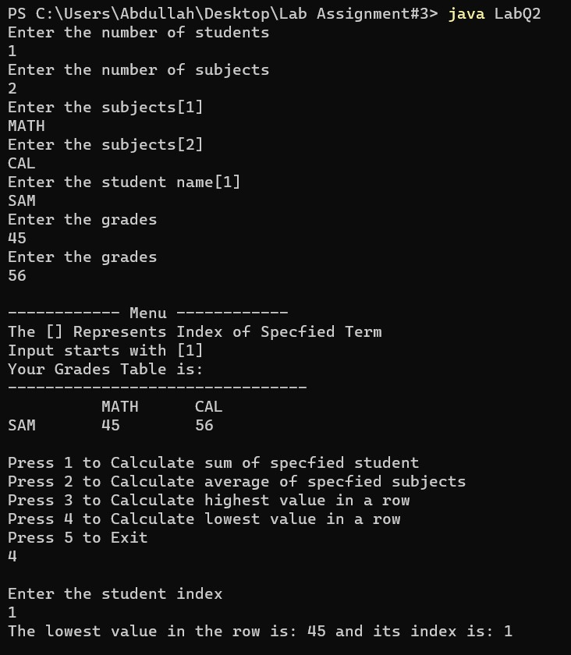

**Question3:**

**Code:**

/*  
Name: !you   
Regstration No: SP21-BCS-OO2  
Lab Assignment: finding the difference of pairs  
*/  
import java.util.*;  
import java.lang.*;  
public class LabQ3{  
 public static void main(String[] args){  
 Scanner input = new Scanner(System.in);  
  
 System.out.println("Enter the length of the array! ");  
 int user = input.nextInt();  
 int[] array = new int[user];  
  
 System.out.println("Enter the array elements! ");  
 for(int i = 0; i < array.length; i++){  
 int user1 = input.nextInt();  
 array[i] = user1;  
 }  
  
 int difference2 = Integer.MIN_VALUE;  
 int difference = Integer.MAX_VALUE;   
 int iPairSmall = 0;  
 int jPairSmall = 0;  
 int iPairLarge = 0;  
 int jPairLarge = 0;  
 System.out.println("----- All the pairs are -----");  
 for(int i = 0; i < array.length; i++){  
 for(int j = i + 1; j < array.length; j++){  
 System.out.println("Pair " + array[i] + "," + array[j] + " has difference " + Math.abs(array[i] - array[j]));  
 }  
 }  
 System.out.println("------------------------------");  
 for(int i = 0; i < array.length; i++){  
 for(int j = i + 1; j < array.length; j++){  
 if(Math.abs(array[i] - array[j]) < difference){  
 difference = Math.abs(array[i] - array[j]);  
 iPairSmall = array[i];  
 jPairSmall = array[j];  
 }  
 }  
 }   
 System.out.println(iPairSmall + "," + jPairSmall + " has smallest difference " + difference);  
 System.out.println("------------------------------");  
 for(int i = 0; i < array.length; i++){  
 for(int j = i + 1; j < array.length; j++){  
 if(Math.abs(array[i] - array[j]) > difference2){  
 difference2 = Math.abs(array[i] - array[j]);  
 iPairLarge = array[i];  
 jPairLarge = array[j];  
 }  
 }  
 }   
 System.out.println(iPairLarge + "," + jPairLarge + " has largest difference " + difference2);  
 System.out.println("------------------------------");  
  
  
  
 }  
  
   
}

**Output:**

